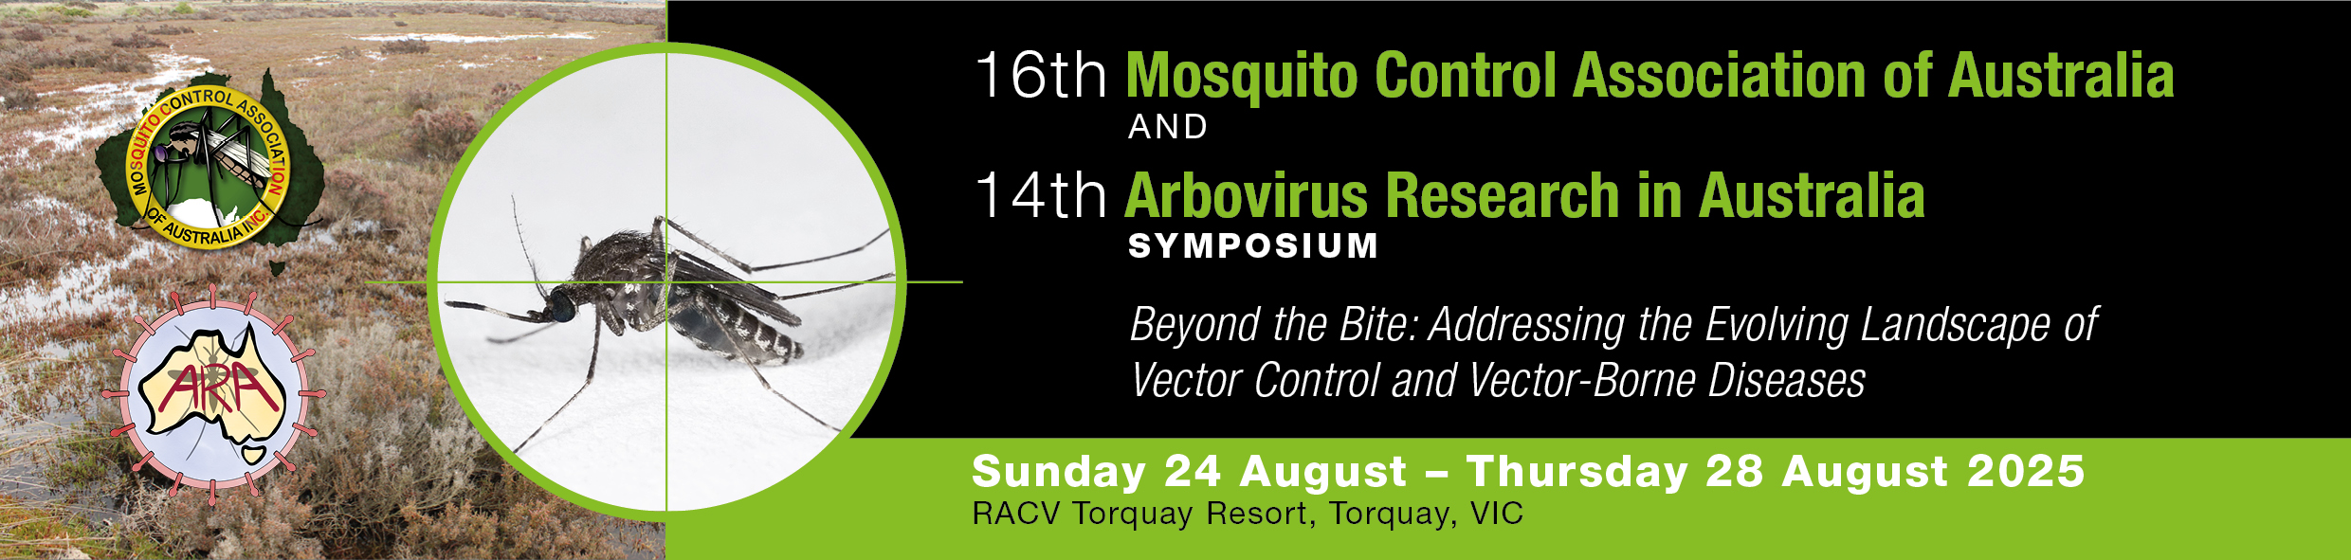

AUTHOR INSTRUCTIONS FOR ABSTRACT SUBMISSION

Please print these instructions and have them close by for reference when you submit your abstract online.

You will need to upload a Microsoft Word version of your abstract when you submit online. Please use the Abstract Template provided. You will also need a short biography (max 50 words) for each presenting authors (not necessary for all co-authors).
Abstract Submission Deadline: 5pm Friday 7 March 2025
Presenter Notifications: Friday 2 May 2025

FORMATTING OF ABSTRACTS
Please note that these formatting guidelines refer only to the Microsoft Word version of your abstract, which will be uploaded as part of the submission process. Prepare your abstract in this Microsoft Word format and save to your computer before starting the online submission process.

All abstracts need to be submitted in the same format. Please use the template provided.
Failure to do so may result in your abstract not being accepted.
All abstracts should be created in Microsoft Word, A4 paper size, Arial font, single spacing, right and left justified for body of text. Abstracts should be a maximum of 300 words.
Title
The abstract title should be short (strictly no more than 12 words), informative and contain the major key words. It should be in Arial, BOLD, 14 pt size, and centre aligned. The abstract title should be in initial capital/lower case, not all capitals.
Authors
Abstract Titles should be followed by authors’ first initial then surname (with the presenting author/s in bold). These should be in Title Case, Arial, 12 pt size, and left aligned. Superscript numbers must be used to indicate the author’s institution or organisation, followed by city and state (in this order). Do not include degrees or professional titles (e.g. Dr, Prof., etc) or post nominals.
See example below:
B Smith¹, M Pattermore^{1,2}, L Ward²
¹University of Sydney, Sydney, NSW
²University of Queensland, St Lucia, QLD

Abstract text
- Abstract text must be in Arial, 12pt size, single-spaced and justified.
- Sub-headings eg Introduction, Method, Results etc may be included if required, however they
will be included in the word count.
- Abstracts are to be a maximum of 300 words, including references.
- There is to be a maximum of 2 references. References should be listed at the bottom of the
page, in Sentence case, Arial, 10 pt size and justified. Please do not use footnotes or superscript numbers within the body of your abstract.
- Use standard abbreviations only. Within the body of the abstract, when using abbreviations spell
out the name in full at the first mention and follow with the abbreviation in parenthesis. Abbreviations may be used in the title, provided the name in full is outlined in the body of the abstract.
- Capitalise the first letter of trade names.
- Do not include images, graphs, tables etc. Text only.
HOW TO SUBMIT YOUR ABSTRACT
Abstract submission will only be accepted via the conference website
www.mcaaconference.com.au

To submit your abstract online you will need the following:

- Your abstract, prepared first in Microsoft Word, adhering to the formatting guidelines listed
above.
- Your brief biography (50 words or less).
- Name, position, organisation and brief biography of any co-authors.

Please note that the main presenting author must be the one to submit the abstract. This is the person all correspondence will be sent to, and, if accepted, this is the name that will appear in the conference program.

To submit your abstract online, please visit the program page of the conference website www.mcaaconference.com.au and click on the “SUBMIT YOUR ABSTRACT HERE” link.
Follow the prompts to create and account the first time you log-in, then follow instructions on each page.

Assistance
If you have any queries or require assistance with the abstract submission process, please contact East Coast Conferences:

Phone: 02 6650 9800
Mobile: 0408 215 469
Email: jas@eastcoastconferences.com.au

